Optimal search strategy does not develop spontaneously with repeated exposure to simulated visual deficit.

Anna Nowakowska

Alasdair D.F. Clarke

Arash Sahraie

Amelia R. Hunt

University of Aberdeen

Corresponding Author:

Anna Nowakowska

Address and email: Room T32, William Guild Building, King’s College, University of Aberdeen. [a.nowakowska@abdn.ac.uk](mailto:a.nowakowska@abdn.ac.uk)

Running Head: Optimal search strategy does not develop spontaneously with repeated exposure to simulated visual deficit

Author note:

Anna Nowakowska, Department of Psychology, University of Aberdeen

Alasdair D.F. Clarke, Department of Psychology, University of Aberdeen

Arash Sahraie, Department of Psychology, University of Aberdeen

Amelia R. Hunt, Department of Psychology, University of Aberdeen

**Abstract**

We previously showed in a series of experiments that healthy participants with simulated visual deficit( hemianopia) are unable to adopt an efficient eye movement strategies when searching for a target object). Yet, a possible explanation is that participants might have not been exposed to the deficit for long enough to develop such strategy. In this study visual information in one hemifield was removed or degraded while participants searched for a line tilted 45° to the right among lines of varying degree of tilt. Importantly, participants completed 5 testing sessions over five consecutive days and received monetary payment for improvements in performance. They also completed an object naming task on the first and last session to clarify if any improvements in search performance translates to other than search task, and a detection task to clarify if any improvements on the task are associated with improved peripheral vision.

Key words:

Visual search, optimality, blindsight, hemianopia

Homonymous hemianopia occurs when vision is lost in half of the visual field in both eyes due to post-chiasmatic brain injury. Not surprisingly, patients with such lateralized field deficits tend to display different scanpaths compared to controls. When scanning the visual world for a target object, patients perform frequent refixations and imprecise saccades, resulting in disorganised scanpaths, longer reaction times, and decreased ability to find the targets altogether (Meienberg, Zangemeister, Rosenberg, Hoyt & Stark, 1981; Zihl, 1995; Zihl, 1999). While viewing naturalistic scenes, patients tend to fixate different spatial regions and make more fixations of shorter duration compared to healthy observers (Ishiai, Furukawa, & Tsukagoshi, 1987; Pambakian, Wooding, Morland, Kennard & Mannan, 2000). Patients also make more saccades towards their damaged hemifield, with these saccades being of shorter latency and amplitude (Pambakian et al., 2000), and nonhuman primates with unilateral ablations of V1 tend to start their visual exploration from their intact visual field (Yoshida, Itti, Berg et al., 2012).

Tant, Cornelissen, Kooijman and Brouwer (2002) compared performance of healthy participants with simulated visual deficit and patients with acquired hemianopia and concluded that defective eye-movements were primarily (but not entirely, see Schuett, Kentridge, Zihl & Heywood, 2009b) elicited by the visual deficit itself.

Indeed, Simpson, Abegg, and Barton showed looked at how visual search patterns adopts to induced visual field deficit in healthy adults. They showed that pattern of fixations shifts to the blind field very quickly, the adaptation occurs withing 25 experimental trials. Previous studies involving simulated hemianopia also showed improvements in reading after brief exposure to simulltaed deficit ( 15 minutess practice; Schuett et al., 2009a, 2009, b).

In our previous studies of simulated hemianopia( Nowakowska, Clarke, Sahraie, Hunt, submitted) we investigated whether healthy participants can spontaneously adopt effective strategies to compensate for information loss. We previously showed in a series of experiments that healthy participants with simulated visual deficit ( hemianopia) are unable to adopt an efficient eye movement strategies when searching for a target object). In this study visual information in one hemifield was removed or degraded while participants searched for a line tilted 45° to the right among lines of varying degree of tilt or an agry face among neutral faces. We found that the proportion of saccades directed towards the blind field increased with the amount of information available in that field. This sighted-field bias was observed when it had a minimal impact on search efficiency, because the target was difficult to find (Experiments 1 and 2), and when the target popped out of the search array (Experiments 3 and 4). In the latter case, eye movements were frequently directed towards the sighted field even though the target was obviously absent, exhibiting surprisingly inefficient search behaviour. We concluded that efficient search strategies to compensate for information loss are not spontaneously adopted by healthy participants. Yet, a possible explanation is that participants might have not been exposed to the deficit for long enough to develop such strategy. Therefore in the current study we investigate whether repeated exposure to simulated visual field deficit leads to the development of the optimal search strategy In the main task completed over the five consecutive days, we directly manipulated the visibility of the target, using search for a line segment at a specified orientation hidden amongst distractor line segments. Target visibility was manipulated by varying the heterogeneity of the distractor line segment orientations. The bias to search the sighted field first persisted even when the target was easy to spot in the periphery, suggesting search strategies are suboptimal, and not sensitive to the amount of potential information that can be gained by moving the eyes into the blind field.

In the detection task which was completed only on Monday( first session) and Friday (last session) our aim was to first confirm that the target on the homogeneous display was indeed homogeneous and popped out of the display and second to estimate whether participants are simply getting better on the task because the target is easier to detect using central ( foveal) vision. To this aim participants saw the same 80 images as in the training task but only for 200 milisecunds. Such short viewing time prevents aprticipants from making eye movenets and forces to make the force choice oon the presence of the target.

In the third task, that was also completed during Monday and Friday session we aimed to estimate if the improvements in performance transfers to other objects/tasks than the ones that participants were trained in over five consecutive days.

Some patients spontaneously adopt some compensatory strategies (Zihl, 1999), and those who do not can be trained to do so. One strategy to compensate for a lateralized field deficit is to saccade as far into the blind field as possible to maximise the proportion of the search area that falls in the sighted field (Pambakian, Mannan, Hodgson & Kennard, 2004; Pambakian, Currie & Kennard, 2005). Encouraging patients to utilize these strategies in real life improves general functioning (based on self- reports, Mannan, Pambakian & Kennard, 2010; Zihl, 1981). Indeed, one of the best predictors of driving hazard detection in hemianopia patients was an increase in the velocity and amplitude of saccades together with a shift of saccades in the blind field (Bahneman, Hamel, Beukelaer, Ohl, Kehrer, Audebert, Kraft & Brandt, 2015). Similarly, large eye movements, and specifically eye-movements directed towards the blind part of the visual field, improved search for specific items in a supermarket (Kasneci, Sippel, Heister, Aehling, Rosenstiel, Schiefer & Papageorgiou, 2014), and in a collision avoidance task (Papageorgiou, Hardiess, Mallot & Schiefer, 2012).

a strategy of making large eye movements into the blind field would be sub-optimal in many circumstances. For example, if the target is in the sighted field. An influential model of visual search proposes that visual information is integrated across the entire visual field, and eye movements are executed to locations that are most efficient for finding the target (Najemnik & Geisler, 2005). This model implies that healthy observers are optimal in visual search, in the sense that each eye movement is executed to the location that will maximally decrease uncertainty about the target location. Clarke, Green, Chantler & Hunt (submitted) demonstrated that a stochastic model of fixation selection can also match human search performance and is far less computationally taxing. Optimality in eye movements has also been called into question by recent examples of complete failures of healthy human observers to adopt efficient eye movement strategies (Clarke & Hunt, 2016; Morvan & Maloney, 2012; Verghese, 2012). It is therefore unclear whether healthy participants (or patients) can be reasonably expected to spontaneously adopt an optimal strategy to cope with visual deficits, or if they require specialized training.

**Method**

*Participants.* Seventeen participants (females=15; age range =19-36; mean age=22.8 ± 3.99) completed the experiment. All reported normal or corrected-to-normal vision. One participant was excluded from further analysis for accuracy rates below chance level.

***Simulated hemianopia task***

Each participant was tested under two experimental conditions: *Blank and*  *Unmodified* (control). Under the masked (*Blank*) condition the eye-tracker sampled the current gaze position online and replaced the part of the display falling to the left or right of current fixation (blocked) with grey background (*Blank)* condition In the *Unmodified* condition (control) eye movements were sampled but no mask was applied.

*Apparatus.* The display was presented on a 17inch CRT monitor with a resolution of 1024x768. Stimulus generation, presentation and data collection were controlled by Matlab and the psychophysics toolbox (Brainard, 1997; Pelli, 1997) run on a Powermac. The position of the dominant eye was recorded using a desktop-mounted EyeLink 1000 eye tracker (SR Research, Canada) sampling eye position at 1000Hz. The length of the entire system’s delay was 1.5ms (time taken from registering a new sample to screen update). The participants were asked to respond by pressing either the left arrow key (for target present trials) or right arrow key (for target absent trials) on a standard keyboard.

*Procedure.* On arrival at the laboratory each participant was asked to read and sign a consent form and was seated alone in a small low-lit room. On the first session participants were told that they would be doing three tasks: an object-naming task, detection task, and a search task, and their eye movements would be recorded while performing the tasks. They were also told that on the Tuesday, Wednesday and Thursday session they will only do the search task and on Friday again all three tasks.

The masking condition (*Blank* and *Unmodified*) and the location of the mask (left or right) were blocked and the block order was randomized. Participants were informed of the condition before they started each block. Participants were instructed to press a space bar with their left hand to initialize each trial and to press the arrow keys with their right hand. Each trial consisted of a black fixation point (letter x) subtending 1.5x2.5cm (1.9°x3.1°), presented at the centre of the computer screen. On the press of a space bar, the fixation point was immediately replaced by the search array, with the mask applied according to the condition. For example, in the right-side mask block the display was increasingly uncovered as the participants moved their eyes to the far right, and as they moved their eyes to the left the screen was increasingly covered with the mask. The display remained on the screen until the participant made their response, or after 60 seconds had elapsed without a response. The display was replaced with the initial fixation point for the next trial 200ms after the left or right arrow key was pressed. Participants completed three of 80 trials (240 trials total):one block masked to the left, one to the right and one block with no mask( *Unmodified* condition). The target was present on half of all trials in each block and the participants’ task was to indicate the presence or absence of a target. All participants were asked to respond as quickly and as accurately as possible. Auditory feedback in the form of a beep immediately followed every incorrect key press. Before each block of trials participants underwent a nine-point eye movement calibration sequence. Participants were not given any information about hemianopia or simulated hemianopia until they finishedthe last session. After participants completed the 3 tasks and the Monday session was over experimenter reminded participants that they would be paid 20 pounds for their participation in the experiment regardless of their performance and added that they would also receive additional £5 if they improved their reaction times compared to their best performance on any previous session and their accuracy stayed at least the same as on the first session (to avoid speed-accuracy trade-off).

***Object Naming task***

This task was introduced to investigate if any improvements in reaction times in the main task( simulated hemianopia) are also transferrable to other tasks/objects.

*Stimuli and procedure.*

*The stimuli were 80images of natural indoor and outdoor scenes ( see example figure X) taken from Clarke and Coco…The images were divided into 2 sets. Each of the images in the two sets was also flipped to avoid any left/right bias in the amount of objects presented. Therefore we had four sets in total, original images from set one, original images from set 2, flipped images from set 1 and flipped images from set2. If participant saw original set one on the first session, he would see flipped set two on the second session, similarly if they saw flipped set one on the first he would see original set 2 on the second (. The full randomisation is shown in table in supplementary materials). Additionally, we simulated hemianopia while participants were doing this task( exactly in the same way as in the search for a tilted line), so that if on the first session participants were doing left hemianopia, on the last session they were doing right, and the other way round, when they were doing right to start with, they were doing left as the second one. Thus in this task we had to hemianopia types(Left, Right), two image types( original, flipped), and two image sets ( set one, set two). For the purpose of data nalysis we collapse across all this variables and only include 2 levels of independent variable: session 1 and session 2. Partcipants wieved the images for four seconds, after which the image disappeared and particiants verbally listed all the objects that they could remember seeing in a particular scene. Participants were encouraged to list as many objects as they could remember. The responses were recorded, and the objects were included accrding to the criteria set in Clarke Coco eta l.*

Participants viewed

***Detection task***

*Stimuli and procedure.*

The 80 search arrays of line segments we used in this experiment were exactly the same as the ones in the simulated hemianopia task

Participants were told they would see line segments on the screen for a very short time, and their task was to determine whether a line tilted 45° to the right was present among other lines. Participants were asked to respond as accurately as possible and to guess if not sure about the answer.

Each trial consisted of a black fixation point (letter x) subtending 1.5x2.5cm (1.9°x3.1°), presented at the centre of the computer screen. On the press of a space bar, the stimulus was displayed for 200ms follow by a blank screen. Participants had to press either the left (present) or right (absent) arrow key. Auditory feedback in the form of a beep immediately followed incorrect key presses. Before the start of the experiment participants underwent a five-point calibration sequence. This task was always carried before the three simulated hemianopia blocks on the Monday session and after simulated hemianopia blocks on the Friday session.

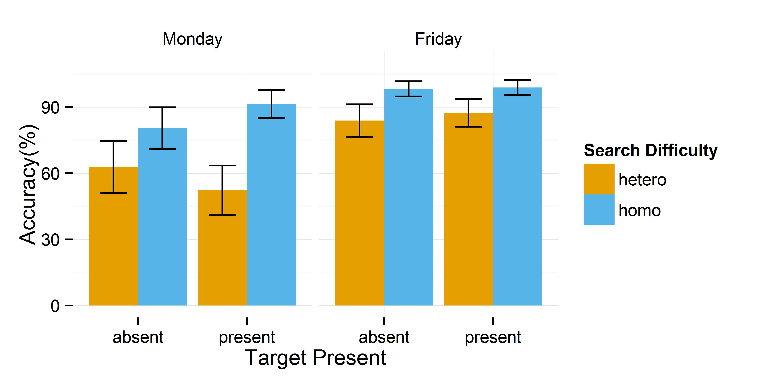**Results**

The accuracy data from the detection task on two sessions are shown in figure x.

Accuracy data was calculated for each participant and was analysed using a 2x2x2 repeated measures ANOVA with Search Difficulty (*Homogeneous, Heterogeneous*), Target Present (*Present*, *Absent)* and Session (*Monday, Friday*) as factors.. This analysis revealed a statistically significant main effect of Search Difficulty [*F*(1,15)=100.97, *p*<.001, $ɳ_{p}^{2}$ =.87], and Session [*F*(1,15)=54.24, *p*<.001, $ɳ_{p}^{2}$ =.78], but not significant effect of Target Present[*F*(1,15)=.17, *p*=.69, $ɳ_{p}^{2}$ =.01] and no statistically significant interaction between the three factors [*F*(1,15)=3.65, *p*=.08, $ɳ_{p}^{2}$ =.20]. Paired sample t-test further showed that on Monday session participants were significantly more accurate on homogeneous displays, regardless whether the target was absent [*t*(15)=2.45,*p*<.03 or present [*t*(15)=5.76,*p*<.001, similarly on Friday session participants were significantly more accurate on homogeneous displays, regardless whether the target was absent [*t*(15)=3.84,*p*<.002 or present [*t*(15)=4.10,*p*=.001. Then we split these data by difficulty instead. On homogeneous trials we observe participants’ accuracy increased significantly on Friday session (compared to the Monday one) when the target was absent [*t*(15)=3.58,*p*=.003] but not when it was present [*t*(15)=2.09, *p*=.06]. On heterogeneous trials we observe participants’ accuracy increased significantly on Friday session (compared to the Monday one) both when the target was present [*t*(15)=6.81, *p*<.001] and absent [*t*(15)=3.47, *p*=.003].

**Results**

To investigate how the different mask-types influence search performance we first carried out an analysis of variance (ANOVA) on reaction time and accuracy. To characterise scanning behaviour we also analysed the number of fixations per trial, saccade amplitude, and the proportion of saccades directed into the blind versus sighted field. For these two latter measures we analysed the target absent trials only, to ensure all saccades in the analysis were search-related and not directed toward the target itself. In these and all subsequent analyses, degrees of freedom were corrected using Greenhouse-Geisser estimates of sphericity wherever necessary. To keep our analyses simple and hypothesis-driven, all additional analyses are included in the supplementary information and will be referred to in the text when relevant[1].

**Discussion**

If, however, the targets were easy to see such that the search would be classified as a pop-out, (Treisman & Gelade, 1984), then there does exist a strategy that will clearly lead to faster target detection, namely: first assess from the centre whether the target is present, and if the target cannot be detected, make a large eye movement into the blind field. If the target were in the sighted field it would be easily detected from the center. Therefore, any eye movements into the sighted field during easy (parallel) search are superfluous and will reveal no new information.

Having established that participants have a preference to search the sighted field first in the first two experiments, the goal of the next two experiments is to ascertain whether participants can adjust this tendency in response to changes in search difficulty. To accomplish this, we shift to using search arrays of line segments rather than faces. The target is a line segment tilted 45 degrees, and difficulty is manipulated by varying the heterogeneity of the orientation of the distractor line segments. Arrays of line segments afford parametric variation of search difficulty

**Experiment 3**

In the third experiment we vary the difficulty of the search from very easy to very hard, to examine whether participants change their search strategy in response to increasing difficulty. When the search is difficult it should not matter whether participants start their search in the sighted or blind field, because they have to inspect the whole display closely (similarly to Experiments 1 and 2) in order to find the target (or indicate its absence). However, under conditions where a target is easy to spot in the periphery, and the target is not immediately visible in the sighted field, it would clearly be inefficient to then move the eyes into the sighted field. Under these conditions, participants *should* move their eyes to the blind field.

**Method**

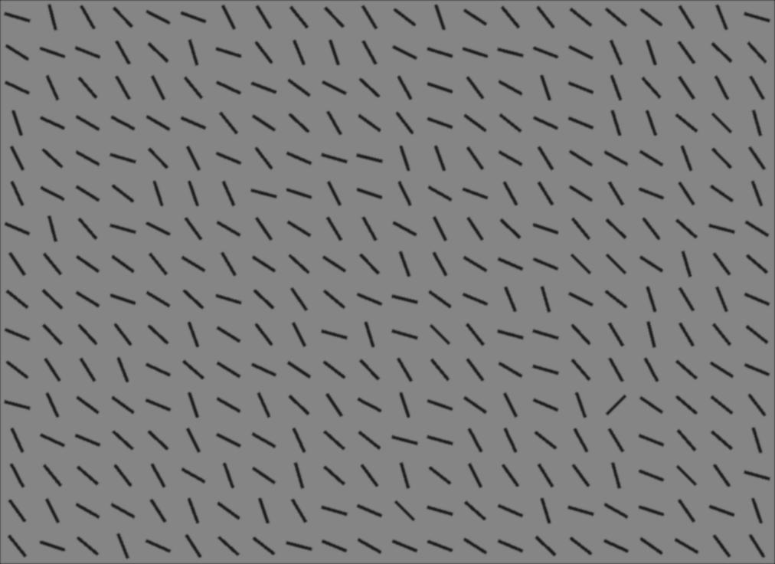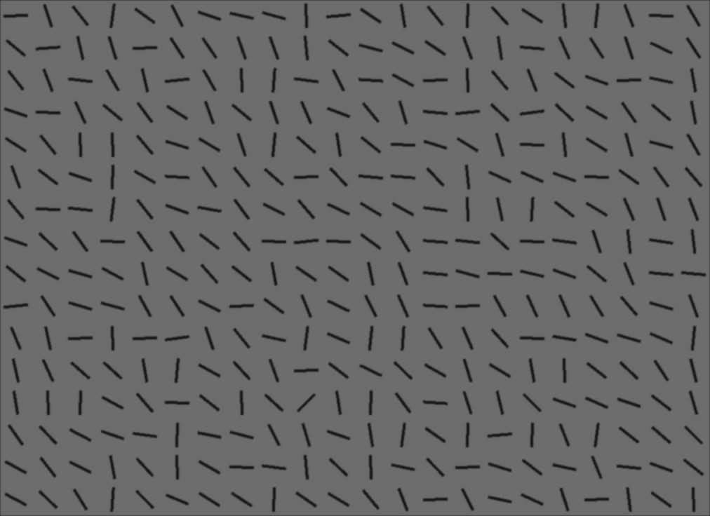

*Figure 7*. Example line segments: left panel represents the stimuli when the target (a line tilted 45˚ to the right) was difficult to find and right panel when the target was easy to find.

*Materials.* The stimuli consisted of 80 pre-generated arrays of line segments. Each line was 1.2cm (1.6°) long. The segments were aligned in 22 columns and 16 rows. The target line was always tilted 45 degrees to the right and the mean distractor angle was perpendicular to the target angle. The target could be located in any of the possible locations apart from the first and last row and column and the middle two rows and columns. Of the 80 images, 40 were target present and 40 target absent. We introduced two levels of search difficulty, with each level corresponding to the distribution from which the distractor line orientation was drawn relative to the target. The distractor angle range of 106° (range of possible distractor angles from the mean orientation) was the hardest condition and the range of 62° was the easiest condition (see Figure 7 for example stimuli). Difficulty included 20 stimuli of each difficulty ()° in both target present and absent conditions. The target was present 20 times on the left and 20 times on the right hand side of the screen. The lines were located on a uniform grey background. The background and mask luminances were matched (17±1 cd/ m²).

Each participant was tested under 20 experimental conditions: two Mask Types (*Blank*, *Unmodified*) and two Mask Sides (*Left*, *Right*). The same set of line segment stimuli was presented in the three conditions (in random order). Participants were informed that the target was a line tilted 45 degrees to the right and they were asked to indicate (by pressing a respective button on a keyboard) whether it was present or absent. They were also given 20 practice trials. Otherwise the procedure and apparatus were exactly the same as in Experiments 1 and 2.

**Results**

The reaction time and accuracy results confirm that our search difficulty manipulation was effective. Nonetheless, participants preferred to saccade first, and more often, into the sighted as opposed to the blind field to a similar extent across the five difficulty levels. When the target was easy to spot in the periphery, and it was not initially visible in the sighted field, participants should have immediately moved their eyes deep into the blind field to search for the target. Yet participants were consistently biased towards the sighted field, irrespective of the ease of target detection. Had participants been able to implement a strategy of searching the blind field when the target was not immediately apparent on easy trials, we would have also seen a decrease in the performance difference between blind- and sighted-field targets with decreasing search difficulty. Instead, this difference is consistently large across search difficulty.

Therefore, in the fourth experiment we only test participants under two conditions: parallel (pop-out) and serial. If the search is easy (it is a pop-out) and the target is initially not visible in the sighted field, the optimal strategy is to make the first saccade deep into the blind field. In the easy condition, participants should be able to tell without making any eye movements (if it is in the sighted field) or with one eye-movement (if it is in the blind field) whether the target is present or absent. Therefore the reaction time difference between target present in the blind and in the sighted field should be about the time it takes to execute one eye movement (about 300ms).

**Experiment 4**

**Method**

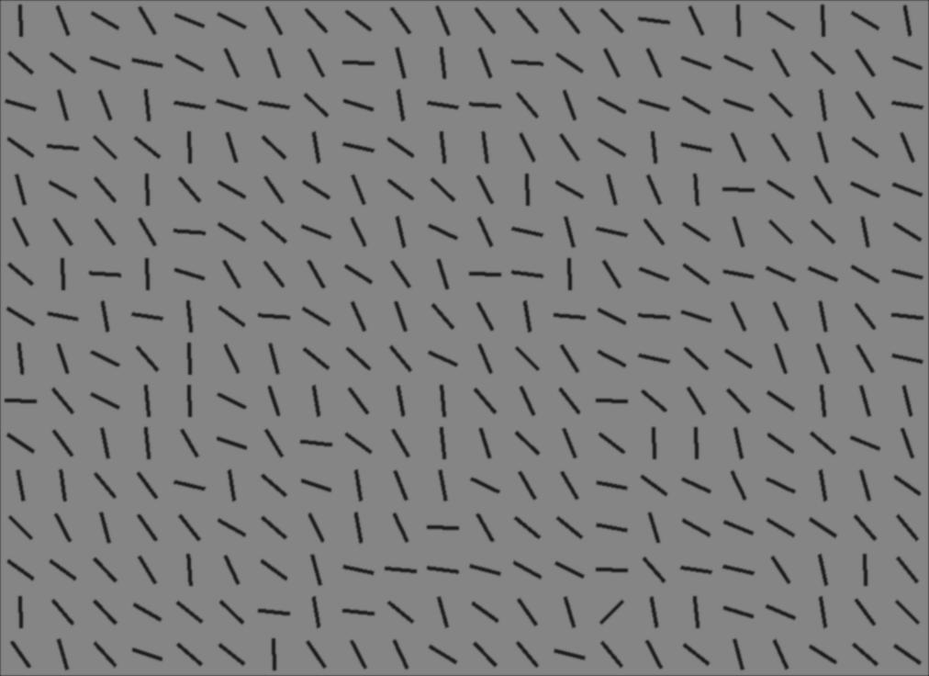

*Discussion*

**General Discussion**

We did observe long term efficiency gains, faster reaction terms and higher accuracy, but these were not associated with optimizing search strategy. Participants started searching the blind field more after the first session but they were near optimal in the sense that they did not concentrate they search on the blind side.

In all four experiments participants were consistently biased towards the visible part of their visual field. In the context of Experiment 1 and 2, this sighted-field bias neither helped nor harmed search performance; but crucially, Experiment 3 and 4 demonstrated that participants continued to direct eye movements into the sighted field even when these eye movements gained them very little new information and impeded search performance.

The proportion of saccades directed towards the blind field increased with the amount of information available (Experiment 1). In the context of visual search models suggesting saccades are directed to locations that maximize information gain (Najemnik & Geisler, 2005), one might have expected complete removal of information to increase saccades towards that region of space, as a saccade in that direction will produce the most information. Nonetheless, it is also well known that the eyes tend to be directed towards salient information (Itti & Koch, 2000), and that directing eye movements towards empty locations is slower and more error-prone than making eye movements towards visible targets (Hallet, 1978; Hallet & Adams, 1980). Our results suggest the tendency to saccade towards salience wins out over strategic saccades that maximize information gain. Similarly, Tant and colleagues suggested that hyperactivation of the intact hemisphere causes a bias towards the sighted field in hemianopic patients (Tant, Kuks, Kooijman, Cornelissen, & Brouwer, 2002b, see also Barton and Black, 1998). This mechanism could also be at work, to some extent, in simulated hemianopia.

In the context of serial search, it may make sense to search the “easier” space first and if the target is still not found, tackle the more difficult space. Consistent with this, we showed that the effectiveness of making large eye-movements deep into the blind field depended on where and what kind of information was present in both the blind and the sighted field. Shifting the location of initial fixation and thus making the display fully visible at the start of the trial (Experiment 2) did not improve search overall: the target was found faster when it was on the blind side but slower when it was on the sighted side, negating the benefits of starting search on the blind side. There are whole treatment protocols designed to increase scanning of the blind field in hemianopia (e.g., Zihl, 1995; Bolognini, Rasi, Coccia & Ladvas, 2005; Papageorgiou et al.,  2012), and it is known that those treatments increase allocation of attentional resources towards the blind hemifield (Kerkhoff, Munssinger & Meier, 1994; see Dundon, Bertini, Ladavas, Sabel & Gall, 2015 for a review). However, the strategy of making large saccade into the area associated with field deficit advocated in the literature (Mannan et al., 2010; Pambakian et al., 2004; Zihl, 1981) failed to produce significantly better outcomes than the one spontaneously adopted by our observers. A more effective approach may be to train patients to rapidly adjust their search strategy to the particular visual context. For example, if the patient is looking for a small object in a cluttered environment, searching the sighted field first may be both more comfortable and more effective. However, for a bright, highly visible object, a large eye movement into the blind field is a reasonable strategy. It is also important to consider situations in which contextual information is available (Kasneci et al., 2014, Papageorgiou, 2012), as these would comprise most search contexts a patient would encounter in the real world. In these situations, eye movements can be directed to likely target locations, and the effect of strategy and salience will be minimal.

The sighted-field bias persisted across search difficulty, which we manipulated by altering the heterogeneity of the distractors (Experiments 3 and 4). This result was surprising because during search for a pop-out target, participants should have executed a large saccade into the blind field on trials where the target was not immediately detected in the sighted field. Similarly, when participants were given location pointers (Experiment 1) an optimal strategy was to make smaller, more precise saccades to the potential target locations in the blind field instead of the large ones that they made in the blank condition. Yet, our participants failed to integrate the information across the entire visual field, instead neglecting the supplied location pointers and continuing search as if no additional information in the blind field were available. It is only when degraded identity information (in the filtered condition) became available that our participants started making significantly more saccades to the “blank” part of the display. Thus we conclude that eye movements in our observers are driven largely by bottom-up visual information and these observers do not switch their preferred search strategy under circumstances when it would be beneficial to examine the area corresponding to the field deficit first.

In Experiments 3 and 4, we manipulated target visibility by varying distractor heterogeneity, and this had no effect on search strategies. In this respect, our participants, similarly to Verghese (2012) and Morvan and Maloney’s (2012) participants, failed to spontaneously adopt an optimal search strategy and maximise information gain with each fixation. Healthy observers do not seem to be armed with the sophisticated search mechanism advocated by Najemnik and Geisler (2005, 2008). Our data are also consistent with the findings from modalities in addition to vision, demonstrating that humans fail to modify their behaviour to cope with changes in task difficulty (in memory, target detection, throwing; Clarke & Hunt, 2016).

How can one explain the discrepancies between the Najemnik and Geisler (2005) findings of optimal search and Janssen and Verghese findings of optimal strategy in matching task (2015) and the ones observing essentially idiosyncratic and/or stimulus-driven search such as that observed in Morvan and Maloney’s (2012) and our study? There are notable methodological differences between our study and that of Janssen and Verghese (2015) studies that make parallel conclusions difficult. Unlike in our study, their participants’ viewing time was restricted to 2 seconds and stimuli disappeared within 300ms of the first eye movement. An optimal strategy was to make the one possible saccade to the area covered by the scotoma. Moreover, participants received immediate feedback on the correctness of their responses and thus on the correctness of their saccadic strategy (Janssen and Verghese’s, 2015). The combination of constraint behaviour choice and direct (immediate) feedback could have supported the adoption of more optimal behaviour in their experiment. It is also potentially quite important that two out of six participants were authors of the study; knowledge about what the optimal behaviour is could certainly make participants more likely to exhibit it. This is also an issue in Najemnik and Geisler (2005) in which the data against which an optimal search model is compared comes from the two authors of the study.

The fact that our participants (and those in other studies) did not spontaneously adopt an optimal strategy has important implications for clinical practice. It could be suggested that patients require specific training to optimize their eye-movements in laboratory and real life search tasks since an optimal strategy does not develop spontaneously. Janssen and Verghese’s (2015) study provides a nice example that it may be possible to teach participants an optimal strategy under constrained conditions by providing immediate feedback. It is important to note two differences between our healthy participant data and patient data, however. Firstly, although our participants prefer to explore their sighted field first, patients tend to spend more time overall looking into the side associated with the deficit. Our participants on the other hand direct more saccades to the side of the screen opposite to the area associated with the deficit. This could be for a number of reasons. Firstly, because of the limited time our observers were subjected to the deficit, a consistent search strategy did not develop. Exposing observers to multiple testing sessions and thus providing extensive practice could serve as a way to test this prediction. Second, and similarly, patients may adapt differently (and more effectively) because they have more at stake. Our participants are aware that their deficit will end with the experiment, but patients would be more motivated to succeed in adapting to a long-term deficit. Third, there may be a particular effect of brain damage over and above the visual deficit that is responsible for the specific eye-movement pattern. Tant and colleagues (2002) admitted that visual deficit is the main but not the only factor that contributes to the abnormal oculomotor behaviour seen in patients. The fourth possibility is that patients move more to the blind field because they possess some residual visual abilities in their damaged field of vision that guide their search more effectively. Since we observed different degrees of search deficit depending on the kind of information preserved in the blanked field we might speculate that presenting healthy participants with a blank screen to simulate field deficit might not be applicable to all hemianopic patients. In support of this interpretation, Tant et al. (2002) showed that for most eye-movements measures (search times, errors, number and duration of fixations) healthy participants with simulated hemianopia were more impaired than patients with hemianopia. They suggested one explanation for this pattern of results was that patients had more time to adapt to their deficit compared to healthy observers. Yet, an alternative explanation would be that healthy participants with simulated hemianopia do not have any residual visual information in their blind side since they were erased by blank space, while at least some patients could rely on spared vision to guide their search.

Similar to other studies that reported on optimality in vision (Janssen & Verghese, 2015) and other modalities (Clarke and Hunt, 2016) we found some individual differences between our participants in that four out of the 20 participants in Experiment 4 adapted their search strategy in response to changing circumstances and started search from the blind field when the search was easy. Zihl (1999), in a study of 70 patients with hemianopia, concluded that the degree to which participants spontaneously compensate for their visual field deficit depends on the extent of their brain injury. We speculate that some variability in the compensatory strategy development or its lack could also be explained by individual differences.

**Conclusion**

Healthy adults deprived of bottom-up information in half of their visual field tend to preferentially move their eyes towards their sighted field of vision. When search is difficult and requires inspection of individual items serially this bias does not harm search performance. When search is easy, and the target is clearly visible in the periphery, saccades towards the sighted field are superfluous and only serve to slow search. Nonetheless, the bias to preferentially search the sighted field persists even in easy search. These results have important implications both for understanding the processes and strategies involved in visual search, and also for devising effective interventions for patients with visual deficits.

**Acknowledgements**

Anna Nowakowska is supported by an ESRC doctoral studentship. A James S McDonnell scholar award to Amelia R. Hunt also provided financial support. We are grateful to Edvinas Pilipavicius and Juraj Sikra for data collection. We also wish to thank W. Joseph MacInnes for help with programming the experiment and Paul Hibbard for help with filtering the faces.

**References**

Bahnemann, M., Hamel, J., De Beukelaer, S., Ohl, S., Kehrer, S., Audebert, H., Kraft, A. & Brandt, S.A. (2015). Compensatory eye and head movements of patients with homonymous hemianopia in the naturalistic setting of a driving simulation. *Journal of Neurology,* 262, 316-325.

Bannerman, R.L., Hibbard, P.B., Chalmers, K., & Sahraie, A. (2012). Saccadic latency is modulated by emotional content of spatially filtered face stimuli. *Emotion*, 12(6), 1384-1392, http://psycnet.apa.org/doi/10.1037/a0028677.

Barbur, J.L., Harlow, A.J., & Weiskrantz, L. (1994). Spatial and temporal response properties of residual vision in case of hemianopia. *Philosophical* *Transactions of the Royal Society of London: Biological Sciences*, 343, 157-166.

Barton, J.J., & Black, S.E. (1998). Line bisection in hemianopia. *Journal of Neurology, Neurosurgery and Psychiatry*, 64(5), 660-662.

Bolognini, N., Rasi, F., Coccia, M., & Ladavas, E. (2005). Visual search improvement in hemianopic patients after audio-visual stimulation. *Brain,* 128, 2830-2842.

Brainard, D.H. (1997). The psychophysics toolbox. *Spatial Vision*,10, 433-436.

Chen, X., & Zelinsky, G.J. (2006). Real-world visual search is dominated by top-down guidance. *Vision Research*, 46, 4118-4133.

Clarke, A.D.F. & Hunt, A.R. (2016). Failure of intuition when choosing whether to invest in a single goal or split resources between two goals. *Psychological Science,* 27, 64-74.

Clarke, A.D.F., Green, P.R., Chantler, M.J., & Hunt, A.R. (submitted). Stochastic search for a target on a textured background.

Dundon, N.M., Bertini, C., Ladavas, E., Sabel, B.A. & Gall, C. (2015). Visual rehabilitation: visual scanning, multisensory stimulation and vision restoration trainings. *Frontiers in Behavioral Neuroscience*, 9, 1-14.

Hallet, P. E. (1978). Primary and secondary saccades to goals defined by instructions. *Vision Research,* 18*,* 1279–1296.

Hallet, P. E., & Adams, B. D. (1980). The predictability of saccadic latency in a novel voluntary oculomotor task. *Vision Research,* 20*,* 329–339.

Itti, L., & Koch, C. (2000). A saliency-based search mechanism for overt and covert shifts of visual attention. Vision Research, 40, 1489–1506.

Ishiai, S., Furukawa, T., & Tsukagoshi, H. (1987). Eye-fixation patterns in homonymous hemianopia and unilateral spatial neglect. *Neuropsychologia,* 25(4),675-679.

Janssen, C.P., & Verghese, P. (2015). Stop before you saccade: Looking into an artificial peripheral scotoma. *Journal of Vision*, 15(5), 1-19, http://dx.doi.org/10.1167/15.5.7.

Kasneci, E., Sippel, K., Heister, M., Aehling, K., Rosenstiel, W., Schiefer, U., & Papageorgiou, E. (2014). Homonymous visual field loss and its impact on visual exploration: A supermarket study. *Transactional Vision Science and Technology*, 3(6), http://dx.doi.org/10.1167/tvst.3.6.2.

Kerkhoff, G., Munssinger, U., & Meier, E.K. (1994). Neurovisual rehabilitation in cerebral blindness. *Archives of Neurology*, 51, *474-481.*

Lundqvist, D., Flykt, A., & Ohman, A. (1998). The *Karolinska directed emotional faces(KDEF)*. Stockholm: Karolinska Hospital.

Mannan, S.K., Pambakian, A.L.M., & Kennard, C. (2010). Compensatory strategies following visual search training in patients with homonymous hemianopia: and eye movement study. *Journal of Neurology*, 257, 1812-1821.

Meienberg, O., Zangemeister, W.H., Rosenberg, M., Hoyt, W.F., & Stark, L. (1981). Saccadic eye movement startegies in patients with homonymus hemianopia. *Annals of Neurology*, 9, 537-544.

Mohler, C.W., & Wurtz, R.H. (1977) Role of striate cortex and superior colliculus in visual guidance of saccadic eye movements in monkeys. *Journal of Neurophysiology,* 40, 74–94.

Moore, T., Rodman, H.R., Repp, A.B., & Gross, C.G. (1995). Localization of visual stimuli after striate cortex damage in monkeys: Parallels with human blindsight. *Proceedings of the National Academy of Sciences of the U.S.A*, 92, 8215-8218.

Morvan,C., & Maloney, L.T. (2012). Human visual search does not maximize the post-saccadic probability of identifying targets. *PLoS Computational Biology,* 8, DOI: 10.1371/journal.pcbi.1002342 .

Najemnik, J., & Geisler, W.S. (2005). Optimal eye movement strategies in visual search. *Nature*, 434, 387-391.

Najemnik, J., & Geisler, W.S. (2008). Eye movement statistics in humans are consistent with an optimal search strategy. *Journal of Vision*, 8(3), 1-14.

Neider, M.B., & Zelinsky, G.J. (2006). Scene context guides eye movements during visual search. *Vision Research*, 46, 614-621.

Pambakian, A.L., Wooding, D.S., Morland, A.B., Kennard, C., & Mannan, S.K. (2000). Scanning the visual world: a study of patients with homonymous hemianopia. *Journal of Neurology, Neurosurgery and Psychiatry,*  69, 751-759.

Pambakian, A.L.M., Mannan, S.K., Hodgson,T.L., & Kennard,C.( 2004). Saccadic visual search training: a treatment for patients with homonymous hemianopia. *Journal of Neurology, Neurosurgery, and Psychiatry, 75*, 1443-1448.

Pambakian, A.L.M., Currie, J., & Kennard, C. (2005). Rehabilitation strategies for patients with homonymous visual field defects. *Journal of Neuro-Opthalmology,* 25, 136-142.

Parker, D.M. , Lishman, J.R., & Hughes, J. (1996). Role of coarse and fine spatial information in face and object processing. *Journal of Experimental Psychology: Human Perception and Performance,* 22, 1448-1466.

Pegna, A.J., Khateb, A., Lazeyras, F., & Seghier, M.L. (2005). Discriminating emotional faces without primary visual cortices involves the right amygdala. *Nature Neuroscience*, 8, 24-25.

Pelli, D.G. (1997). The videotoolbox software for visual psychophysiscs: transforming numbers into movies. *Spatial Vision*, 10,437-442.

Pomplun, M., Reingold, E.M., & Shen, J. (2003). Area activation: a computational model of saccadic selectivity in visual search. *Cognitive Science*, 27, 299-312.

Riddoch, G. (1916). On the relative perception of movement and a stationary object in certain visual disturbances due to occipital injuries. *Proceedings of the Royal Society of Medicine*, 10, 13-34.

Riddoch, G. (1917). Dissociation of visual perceptions due to occipital injuries, with especial reference to appreciation of movement. *Brain*, 40, 15-57.

Rutishauser, U., & Koch, C. (2007). Probabilistic modelling of eye-movement data during conjunction search via feature-based attention. *Journal of Vision*, 7(5), 1-20, doi:10.1167/7.6.5.

Sahraie, A., Hibbard, P.B., Trevethan, C.T., Ritchie, K.L., & Weiskrantz, L. (2010). Consciousness of the first order in blindsight. *Proceedings of the National Academy of Sciences of the U.S.A*, 107, 21217- 21222.

Sahraie, A., Trevethan, C.T., MacLeod, M.J., Urquhart, J. & Weiskrantz, L.(2013). Pupil responses as a predictor of blindsight in hemianopia. *Proceedings of the National Academy of Sciences of the U.S.A*, 110, 18333-18338.

Schuett, S. Kentridge, R.W., Zihl, J., & Heywood, C.A. (2009a). Adaptation of eye-movements to simulated hemianopia in reading and visual exploration: transfer or specificity? *Neuropsychologia,* 47, 1712-1720

Schuett, S. Kentridge, R.W., Zihl, J., & Heywood, C.A. (2009b). Are hemianopic reading and visual exploration impairments visually elicited? New insight from eye-movements in simulated hemianopia. *Neuropsychologia,* 47, 733-746.

Schuett, S. Kentridge, R.W., Zihl, J., & Heywood, C.A. (2009c). Is the origin of the hemianopic line bisection error purely visual? Evidence from eye movements in simulated hemianopia. *Vision Research,* 49(13), 1668-1680.

Schyns, P., & Oliva, A. (1999). Dr. Angry and Mr. Smile: when categorization flexibility modifies the perception of faces in rapid visual presentation. *Cognition*, 69, 243-265.

Sergent, J. (1985). Influence of task and input factors on hemispheric involvement in face processing*. Journal of Experimental Psychology: Human Perception and Performance*. 11, 846-861.

Simpson, S.A., Abegg, M., & Barton, J.J. (2011). Rapid adaptation of visual search in simulated hemianopia. *Cerebral Cortex,* 21, 1593-1601.

Tant, M.L.M, Cornelissen, F.W., Kooijman, A.C., & Brouwer, W.H. (2002). Hemianopic visual field defects elicit hemianopic scanning. *Vision Research*, 42, 1339-1348.

Tant, M.L.M., Kuks, J.B.M., Kooijman, A.C., Cornelissen, F.W., & Brouwer, W.H. (2002b) Grey scales uncover similar attentional effects in homonymous hemianopia and visual hemi-neglect. *Neuropsychologia,* 40, 1474-1481.

Treisman, A.M., & Gelade, G.A. (1980). A feature-integration theory of attention. *Cognitive Psychology*, 12, 97-136

Trevethan, C.T., Sahraie, A., & Weiskrantz, L. (2007a). Form discrimination in a case of blindsight. *Neuropsychologia,* 45, 2092-2103.

Trevethan, C.T., Sahraie, A., & Weiskrantz, L. (2007b). Can blindsight be superior to ‘sighted-sight’? *Cognition,* 103, 491-501.

Verghese, P. (2012). Active search for multiple targets is inefficient. *Vision Research*, 74, 61-71.

Vuilleumier, P., Armony, J.L., Driver, J., & Dolan, R.J. (2003). Distinct spatial frequency sensitivities for processing faces and emotional expressions. *Nature Neuroscience*, 6, 624-631.

Weiskrantz, L. (1986). *A case study and implications,* Oxford: Oxford University Press.

Wolfe, J.M. (1994). Guided search 2.0- A revised model of visual-search. *Psychonomic Bulletin & Review*, 1, 202-238.

Yoshida, M., Itti, L., Berg, D.J., Ikeda, T., Kato, R., Takaura, K., White, B.J., Munoz, D.P., & Isa, T. (2012). Residual attention guidance in blindsight monkeys watching complex natural scenes. *Current Biology*, 22, 1429-1434.

Zelinsky, G.J. (2008). A theory of eye movements during target acquisition. *Psychological Review*, 115, 787-835.

Zihl, J. (1981). Recovery of visual function in patients with cerebral blindness. Effect of specific practice with saccadic localization. *Experimental Brain Research*, 44, 159-169

Zihl, J. (1995). Visual scanning behaviour in patients with homonymous hemianopia. *Neuropsychologia,*  33, 287-303.

Zihl., J. (1999). Oculomotor scanning performance in subjects with homonymous visual field disorders. *Visual Impairment Research,* 1, 23-31.

1. We recognize that more detailed comparison of target absent vs. present conditions may be relevant to questions about the effect of self-terminating vs. exhaustive search. This is beyond the scope of the current study, but for those interested, detailed results are reported in the supplementary data for experiments 1, 2, and 4, including all post-hoc tests.